**JUNCTION OF MOSHI-ARUSHA AND NAIROBI ROADS**

**P.O BOX 296, ARUSHA TANZANIA.**

**TEL. +255-27-2503040/2502076 FAX: +255-27-2548337**

**WEBSITE: http://www.atc.ac.tz, Email:** [**principal@atc.ac.tz**](mailto:principal@atc.ac.tz)**.**



**INFORMATION COMMUNICATION TECHNOLOGY DERPATMENT**

**ORDINARING DIPLOMA IN COMPUTER SCIENCE**

**FINAL YEAR PROJECT 2014/2015**

**PROJECT TITLE: CRIME INFORMATION MANAGEMENT SYSTEM.**

**PRESENTED BY: ADMISSION NO:**

**EMANUEL SARUN A0120195**

**JOHN MICHAEL A0120205**

**GILBERT MALUKU A0120200**

**NTA LEVEL: 6**

**SUPERVISOR: MR.SIMALIKE**

**ACKNOWLEDGMENT**

We are indeed thankful to God Almighty for his grace upon us throughout our period of our project. We pray that he will continue to guide and protect us throughout our academic and future endeavor in GOD name (AMEN).

My most sincere gratitude and acknowledgment goes to our wonderful supervisor Mr**. Simalike** who has guided us in preparing this project book. Also my lectures in the department of ICT most especial to our H.O.D Mr.Mmari and finally all our concrete members including Emanuel sarun, john Michael, Gilbert maluku Tumaini Erenest, Elimbingi Masawe, Florian Kipeta, Daudi Nyanda (CR-BBM),Casmir Mango (CR). Also my good family friends Miss Neema Mollel(ict 2nd year), Hamisa Mtungi, Julia Msuya all my well wishers for your encouragement may God bless you all and grant your heart desires Amen.

**ABSTRACT**

This project book intends to automate the existing criminal records of the Tanzania police. The essence was to produce durable criminal records and avoidable lost of criminal records. Structural database management system (DBMS) was used in its development in other to eliminate redundancy in the compilation, its friendliness in responding to the user exhibits and also its reliability and efficiency in tracking down criminals.

Another important feature of this Crime Information Management System is that it provides user with the facilities for having the hard copies or print out of any relevant document as well as the facilities to communication with the system.

Tracking is the observing of persons or objects on the move and supplying a timely ordered sequence of respective location data to a model e.g. capable to serve for depicting the motion on a display capability. The traditional and age-old system of criminal record and file processing has failed to live up to the requirements of the existing crime scenario. Manual processes neither provide accurate, reliable and comprehensive data round the clock nor does it help in trend prediction and decision support.

# 

# DECLARATION

We student of Arusha Technical College, in Information and communication technologies department, pursuing Diploma in Computer science. Hereby declare that all the whole work described in this project book is our own, except where explicitly indicated otherwise.

Wherever information from other sources is included, the references material source is also given.

# APPROVAL

We certify that this project book is our own work and is submitted with our approval.

*PROJECT PARTICIPANT SIGNATURE*

Mr. EMANUEL SARUN ……………………………...

Mr. JOHN MICHAEL …………………....................

Mr. GILBERT MALUKU ………………………………

*SUPERVISOR NAME:* MR.PETER SIMALIKE

*SIGNATURE:* ........................................

*DATE:* …………………….........

TABLE OF CONTENTS

ACKNOWLEDGEMENT………………. 2

ABSTRACT……………………………………………………………………………...3

DECLARATION…………………………………………………………….…………..4

APPROVAL……………………………… 5

TABLE OF CONTENT…………………………. 6

CHAPTER 1: Introduction...............................................................................................7

Background of the project 7

Challenge overcomed 8

CHAPTER 2:Proposed System……………………………………………………….....9

The general Objectives of the project 9

The specificobjectives of the project…………………………………………………… 9

Scope of the project 9

Justification …………………………………………………………………………….9

CHAPTER 3: Project Design……………. 11

Project module……………………………………………………………………………11

Administrator module 11

User module 11

Use-case diagram for crime file management system…………………………………...12

System Testing…………………………………………………………………………….13

CHAPTER 4:System Implementation….. 12

Choice of Development Tools 12

Tools Used In Developing the system……………….……………………………………12

Software used …………………………………………………………………………….12

Language Used………….…………………………………………………………………12

System Description…………………………………………………………………….. 12

Administrator Panel……………………………………………………………………….15

User Panel………………………………………………………………………………….24

CHAPTER 5: Challenges………………... 28

Time………………………………………………………………………………………..28

Cost…………………………………………………………………………………………28

CHAPTER 5: Conclusion ………………... 29

Summary 29

way Forward 29

Definition of the term……………………………………………………………………..29

# CHAPTER 1: INTRODUCTION

## Background of the project

Maintaining peace and harmony in the society, man has to fashion out conduct and some laws to govern the conduct of members of the society. When people appreciate these codes of conduct and laws, protection of lives and properties are guaranteed.

Generally tracking is the observing of persons or objects on the move and supplying a timely ordered sequence of respective location data to a model e.g. capable to serve for depicting the motion on a display capability.

The traditional and age-old system criminal record and file processing has failed to live up to the requirements of the existing crime scenario. Manual processes neither provide accurate, reliable and comprehensive data round the clock nor does it help in trend prediction and decision support. It also results in lower productivity and ineffective utilization of manpower. The solution to this ever-increasing problem lies in the effective use of Information Technology. Crime File Management System uses computer-generated records as an interface for integrating and accessing massive amounts of location-based information.

Crime File Management System helps identify potential suspects to increase investigators suspect base when no leads are evident. The ability to access and process information quickly while displaying it in a spatial and visual medium allows agencies to allocate resources quickly and more effectively. In the mission critical nature of law enforcement, information about the location of a crime, incident, suspects. Crime File Management System helps easy co-ordinate large amounts of data or information records from database.

It is used world over by police departments in other country, both large and small, to provide solutions for crime analysis, crime file tracking, file processing, and numerous other tasks.

Traditionally, these activities have been supported by paper and pen. Police officers now will have the ability to immediately generate crime report directly relevant to the situation at hand.

Generally, the book is aimed to develop a crime Information management system that will maintain computerized records of all the FIR against crime .The system can be accessed throughout the police department. This system can be used as an application for the crime file of the police department to manage the records of different activity of related to first information report .

The system manage all such activities (like registration of complaint updating

Information, search of particular viewing of the respective reports of crimes) that will save time,

Manpower.

This system provide better prospective for the enhancement of organization.

## Challenge Overcomed

The Tanzania Police has an existing Crime file system, but this system is not automated. The documentation of criminal records is done on paper and pen. The storage of these criminal records is not something to write home about.

Case files are dumped in heaps while some are kept on shelves. With the moldy nature of the state such important documents quickly get dusty and because of lack of proper storage, some criminal documents are seriously damaged by rats that feed on them. With this kind of situation, it becomes highly difficult if not impossible to track down known criminal, access past criminal history of a suspect and know the status of some concluded cases.

1) Design and develop a database system that would serve as repository of criminal data. Police station will be networked to the central database to access criminal data on cases. This database system will be updated by local police station

2) The database system will capture detailed information about crime suspect right from the time the crime was reported at the police down to the point the suspect appears before the court for prosecution as thereafter.

4) The systems will posses features that will enable criminal data to be purged from the system, updated and queried.

4) The system can easily track all information

-all the complaint details

-criminal details

-FIR Details (first information records)

# CHAPTER 2: PROPOSED SYSTEM

**The general Objective of the project**

The main objective of this Crime Information Management System is to easy track of the criminal information and easy fetching of information stored on the server databases

### 

### The specific Objective of the project

The objectives of this system can broadly be listed as follows:

1. Tracking all complaints details
2. Tracking all criminal details
3. Tracking FIR (first information records)
4. Tracking postmortem records
5. generating varies information reports

**Scope of the project**

The system is a Reporting application that used for automating the manual process of register different case in police stations .This system manage the details of all the crime registered in police station. The system provides an interface to store the crime details of criminals and allows the user to search and view varies records.

The system greatly simplify the overall procedure of crime files.

This Crime Information Management System is designed to be applicable for our country in TANZANIA POLICE stations.

**Justification**

Implementation of a Crime Information Management System by the Tanzania police helps the police and the masses to get useful information on individuals with crime records. The system developed among other things:

1. Maintain a database of all crime records

2. Enable a quick search on the database to retrieve crime information

3. Enable Tanzania police to track previous crimes committed by a suspect

4. Make crime control easier for the police

# CHAPTER 3: PROJECT DESIGN

Design is the first step in the development phase for any techniques and principles for the purpose of defining a device, a process or system in sufficient detail to permit its physical realization.

The software design involves three technical activities - design, coding, implementation and testing that are required to build and verify the software.

The design activities are of main importance in this phase, because in this activity, decisions ultimately affecting the success of the software implementation and its ease of maintenance are made. These decisions have the final bearing upon reliability and maintainability of the system. Design is the only way to accurately translate the customer’s requirements into finished software or a system.

Design is the place where quality is fostered in development. Software design is a process through which requirements are translated into a representation of software. Software design is conducted in two steps. Preliminary design is concerned with the transformation of requirements into data.

**PROJECT MODULES**

List of modules used in crime file management system

- Administrator Module

- User Module

**Administrator Module**

- Admin can register the operator/police’s/users who will be the user of the system. This users are the one who will register all the information reported to the station.

- Admin can delete a user in case a user is not more available to the station or sometimes death of a user

-Admin can view all criminal’s information registered on the system.

-Admin can view all the information reports registered on the system which are criminal report, complain report, FIR report, suspect report, postmortem report, most wanted report

**User Module**

**-** User can registrar all the complains reported to the station by the people

-User can add all the First Information Report received to the station.

-User can registrar all the criminal received to the station

-User can add postmortem report

-User can add suspected people information

-User can Most Wanted People

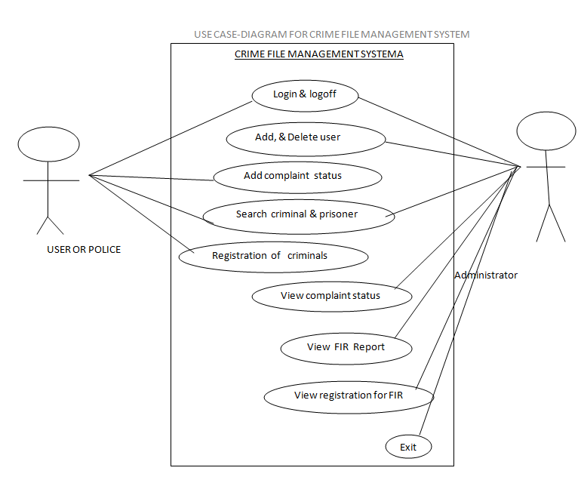

The different unit of this project was tested by different individuals and its workability for perfectly approving which makes the whole system successfully. This comprise of the test data, expected test result and actual test result.

**System Testing**

System testing of software or hardware is testing conducted on a complete, integrated system to evaluate the system's compliance with its specified requirements. System testing falls within the scope of black box testing, and as such, should require no knowledge of the inner design of the code or logic. In this, the accuracy of the program will be tested with some varying data. This will give the assurance that the new system has achieved its purpose and objectives.

# CHAPTER 4: SYSTEM IPLEMENTATION

**Choice of Development Tools:**

So many programming languages were considered in the cause of designing this software. A lot of factors were put into consideration which includes data transmission via networks, database security, database retrieval online, multi user network access, etc.

The choice Web Programming languages was made to enable us achieves the above set objectives. Moreover, Web programming languages are very user friendly and enable the design of an interface that can be modified programmatically. MySql is a robust database that can guarantee database integrity and database protection,

Several Web Programming languages were used in the development of this software. This is because the languages has the advantage of easy development, flexibility, and it has the ability of providing the developer/programmer with possible hints and it produces an attractive user interface.

**Tools used in developing the system**

In order to realize this project, the following languages and software components were used:

**Software Used:**

* Operating System
* WAMP SERVER
* Adobe photo shop
* Sublime text editor

**Languages Used:**

* PHP, CSS, HTML,

**System Description**

Start:

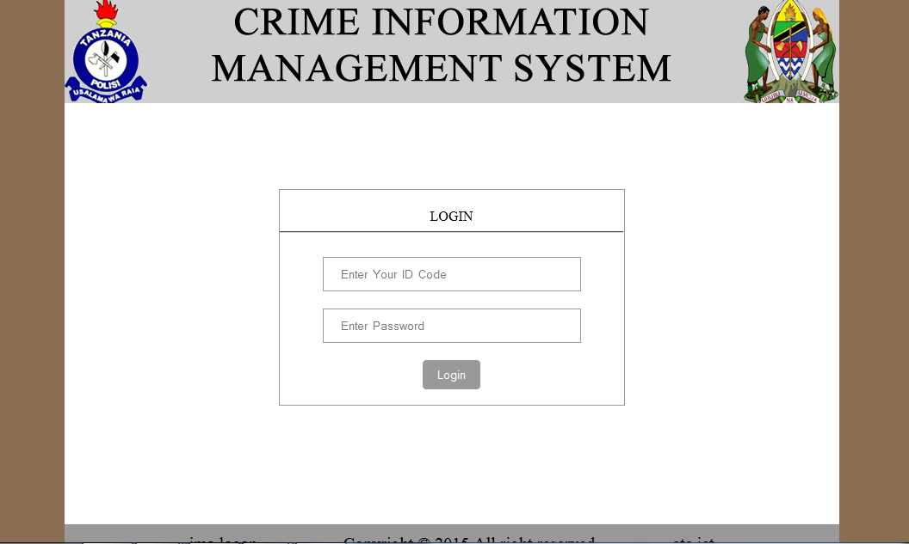

This is a place where by users can login to the system, by providing user Id Code and their passwords.

**Administrator Panel:**

**Add User:**

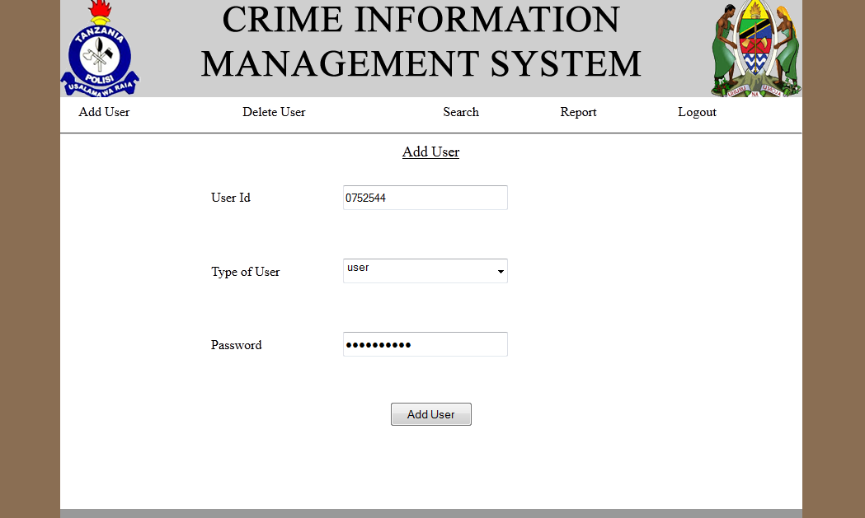

We login as administrator:

here we can add user by providing User Id, type of the user and Password where by user id and Password will be used to login to the system of which the user can add all the information received to the station.

**Delete User:**

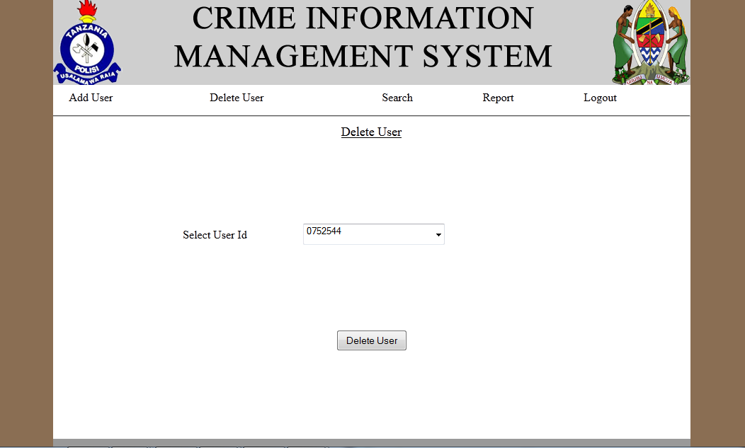

Here Admin can be able to delete user who using the system, of which is no longer be able to access the system.

**Search:**

Here admin can be able to search and view information of registered criminal in system

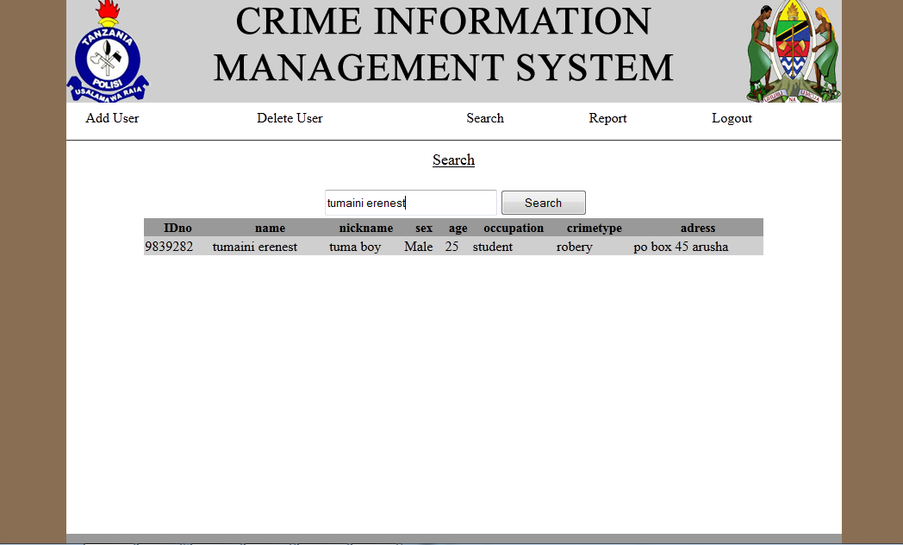

**Report:**

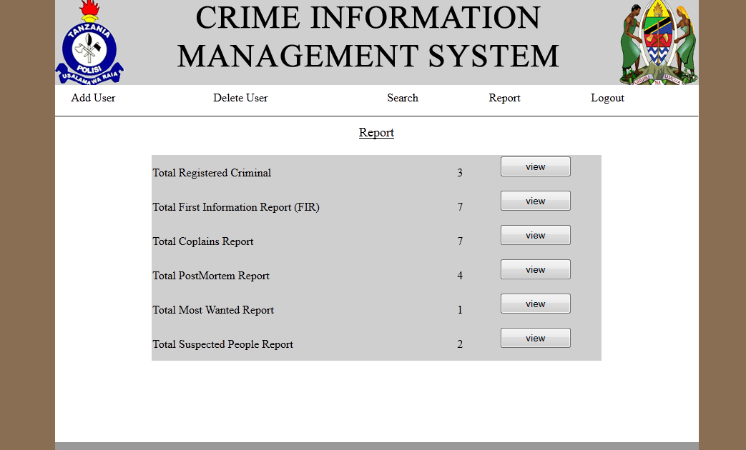

Here admin can view all the total report of registered criminal, FIR, Complaints report, Postmortem report, most wanted report and suspected people report.

**Criminal Registered Report:**

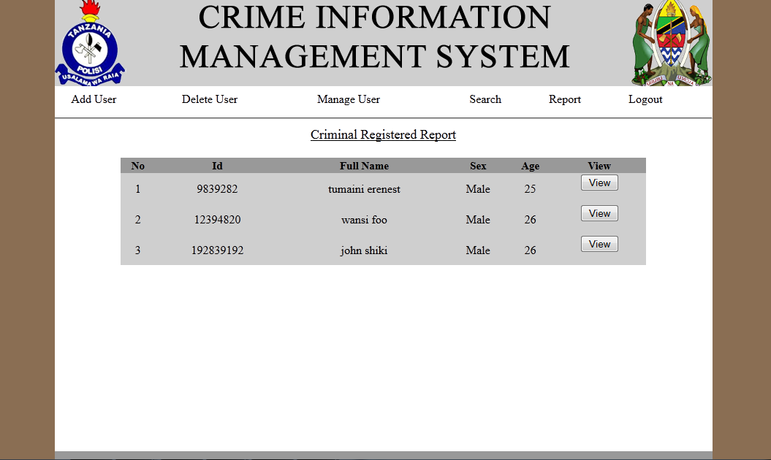

Here admin can be able to view all Criminal Registered Report

**Individual Criminal registered :**

**First Information Report (FIR):**

Here admin can be able to view all FIR

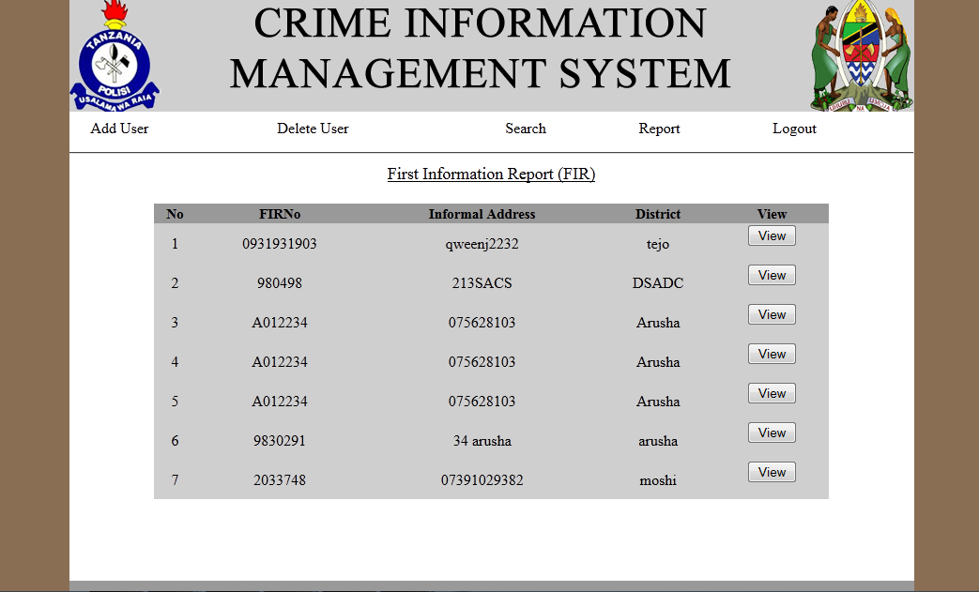

**Single FIR:**

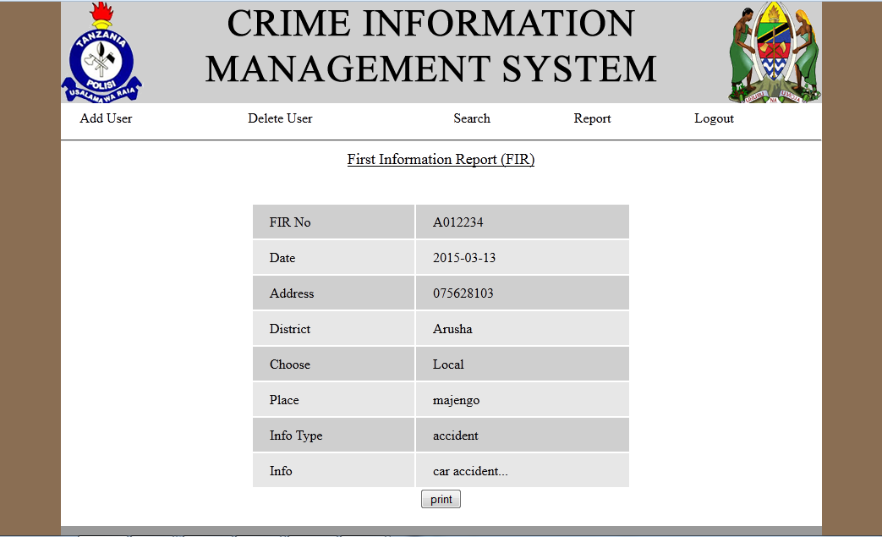

Here Admin can view a single fir report

**Complains Report:**

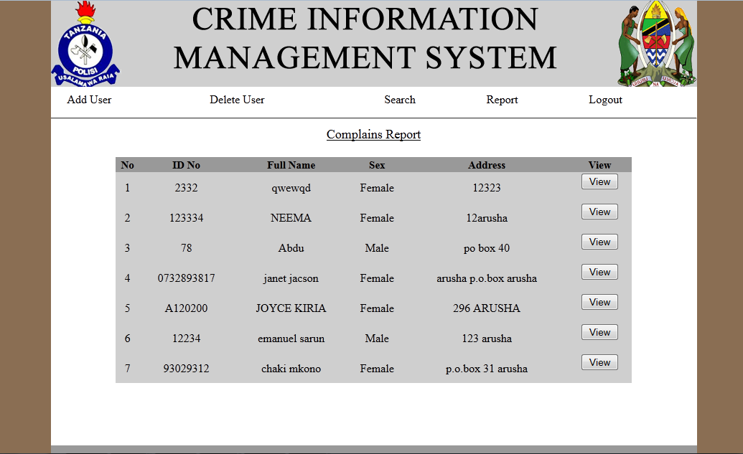

Here Admin can view all the complains tracked by the system

**Viewing Single Complain Report:**

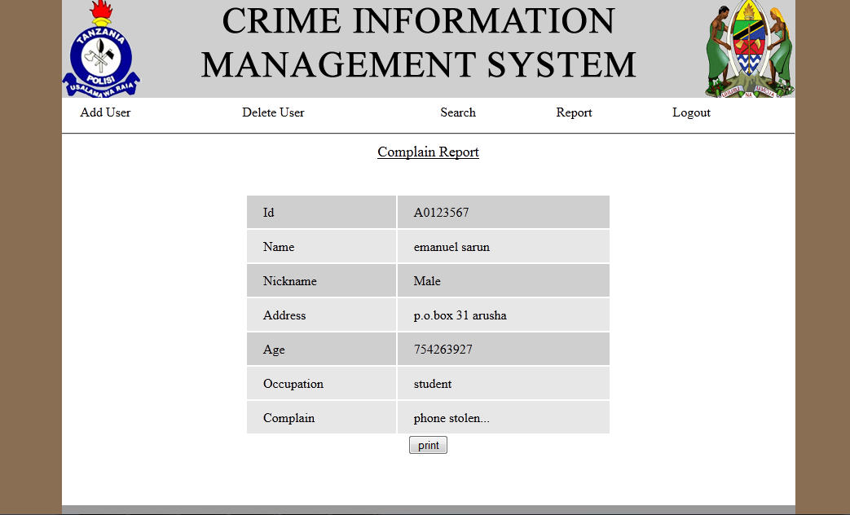

**Postmortem Report:**

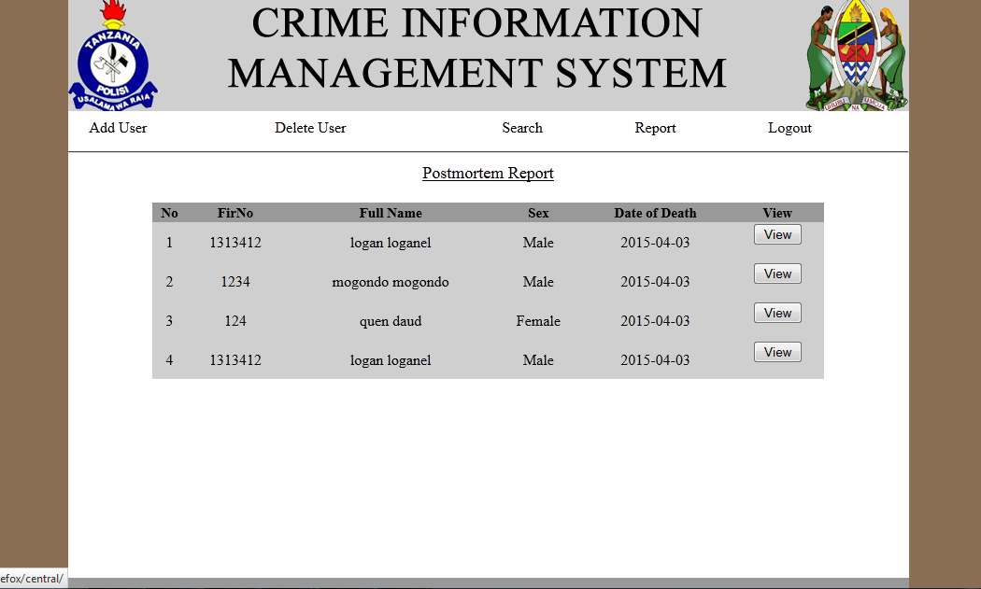

Here shows the all postmortem Report registered in system

**Viewing Single Postmortem Report:**

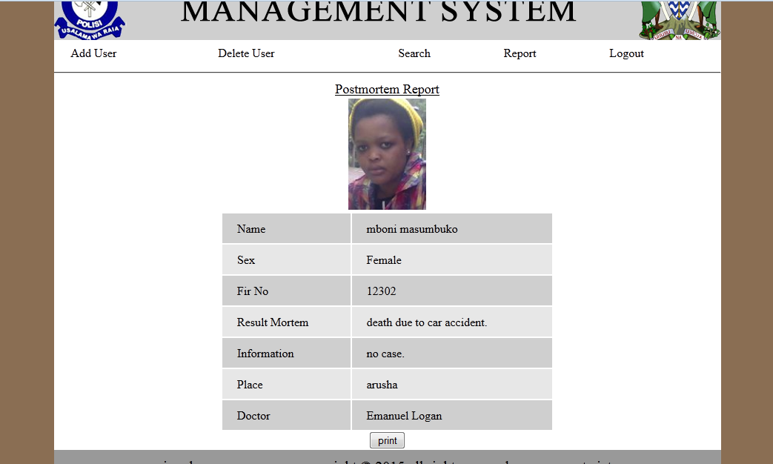

**Most Wanted Report:**

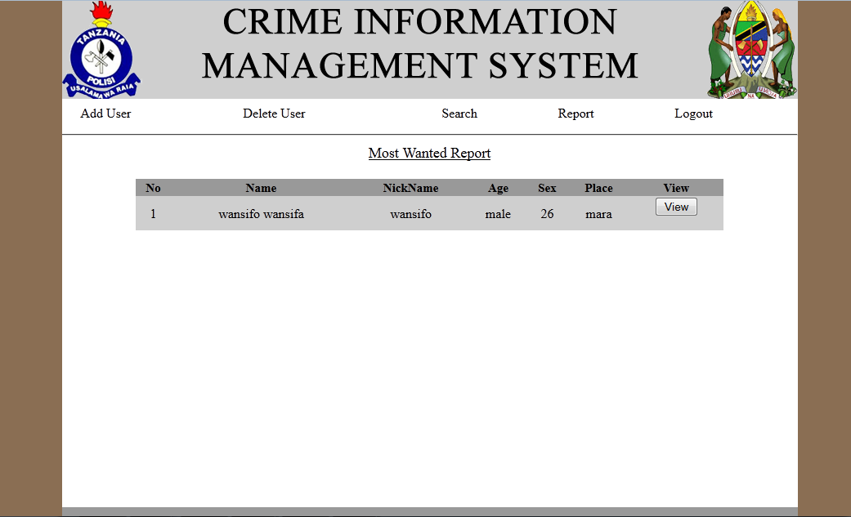

Here we can view most wanted people (this are criminals who are very needed by the police station)

**Individual Most Wanted Person:**

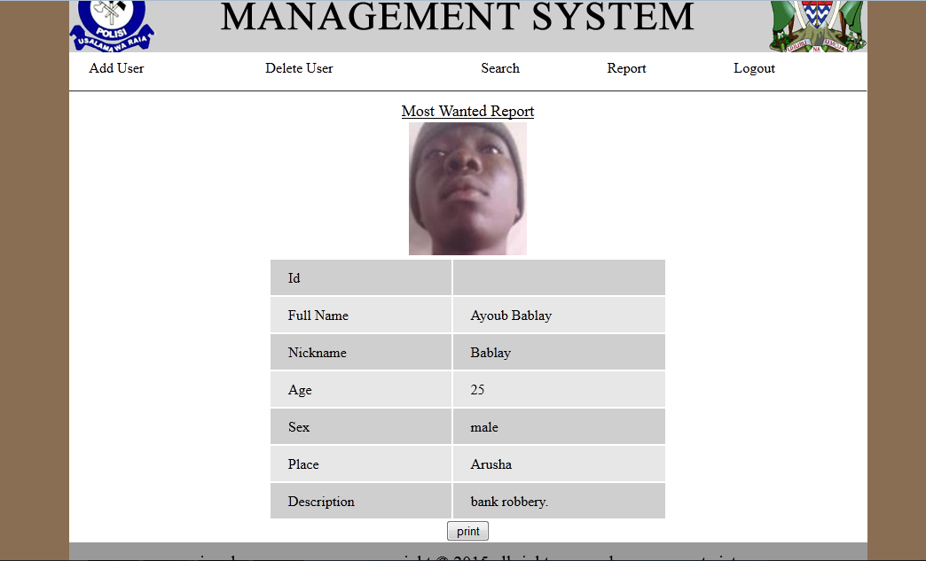

This is a report of a single person showing more details information about a he/she

**Suspected People's Report:**

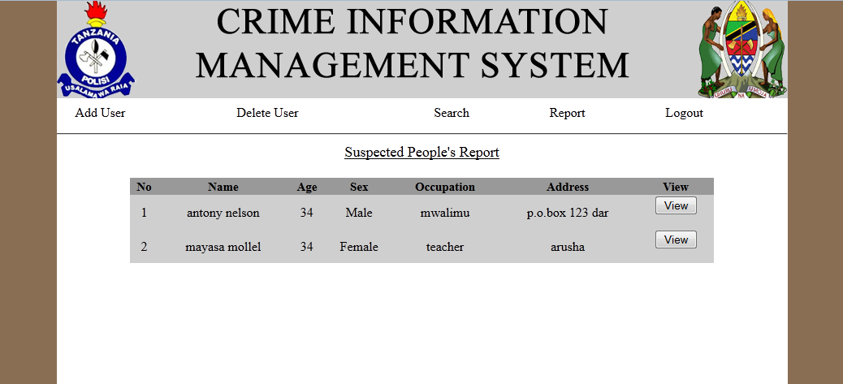

This shows the information about the suspected peoples.

**Individual Suspected People:**

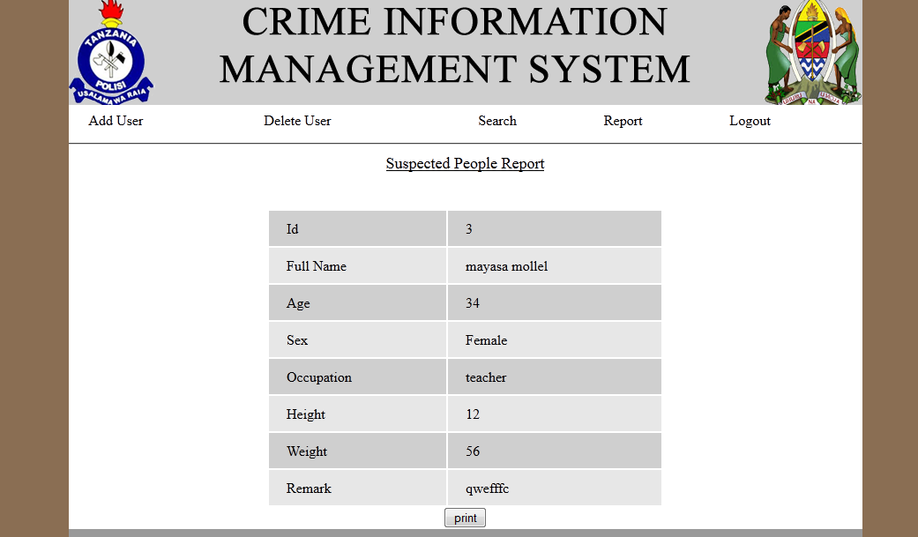 This shows a single detailed information about the suspected person

**User Panel:**

**Complaints Status:**

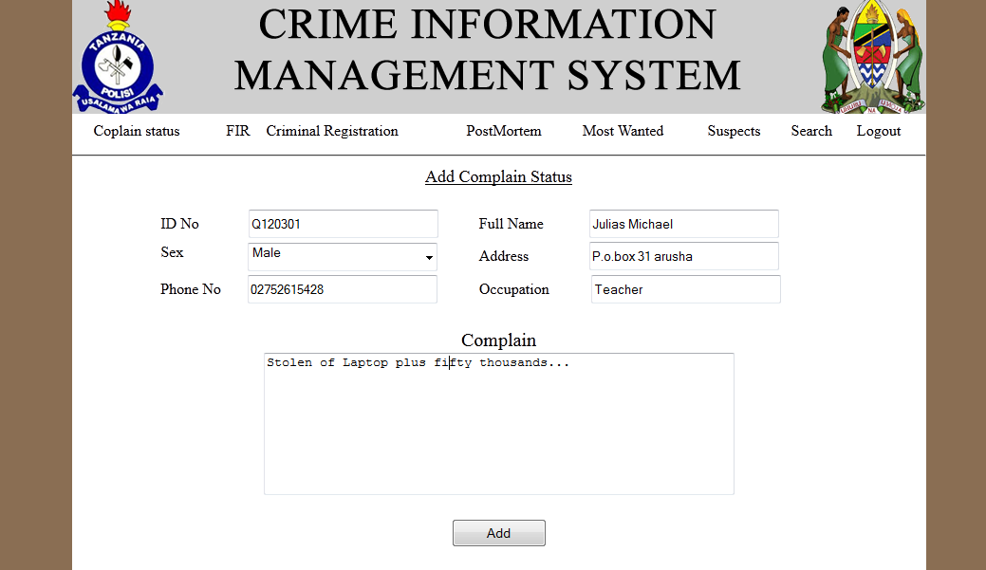

Here user can add complain status received by the station

**First Information Report:**

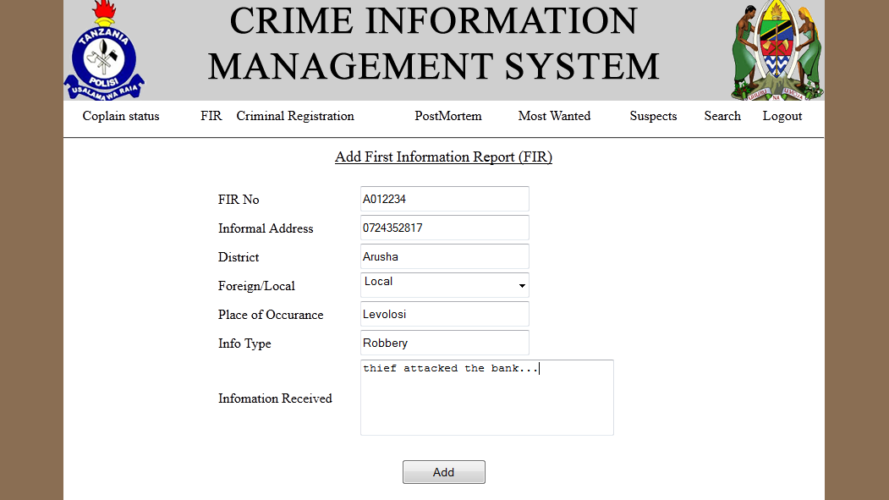

Here user can add the first information report (FIR) about criminal event occurring somewhere

**Register Criminal:**

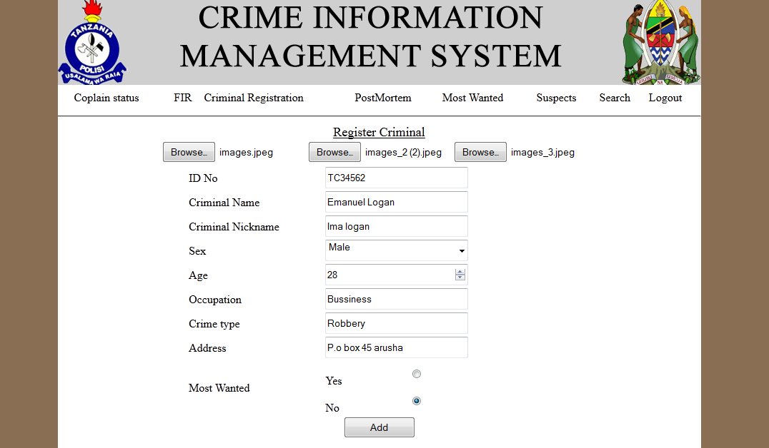

Here user can register a criminal arrived to the police station by taking its detailed information as shown above

**Postmortem:**

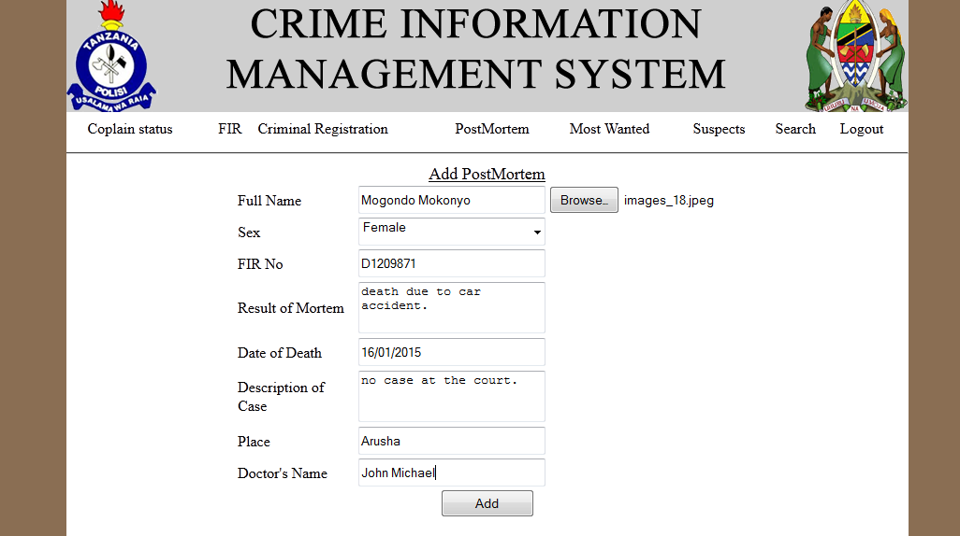

Here user can add a death report for a death of a person

**Most Wanted People:**

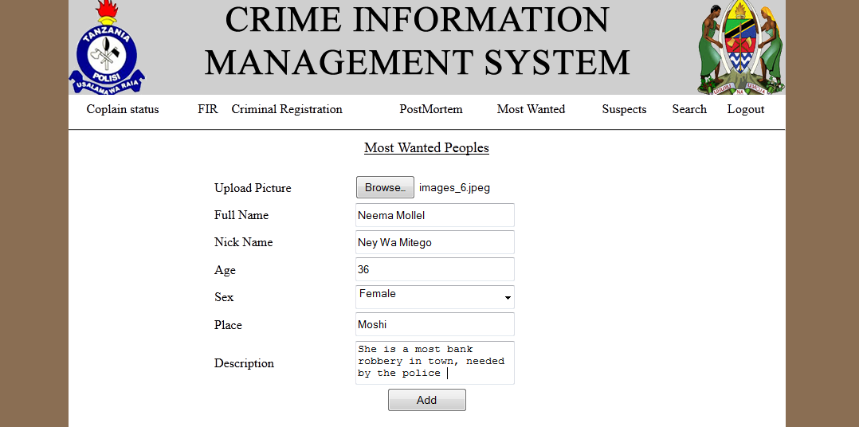

Here user can add a most wanted criminal information

**Suspected People:**

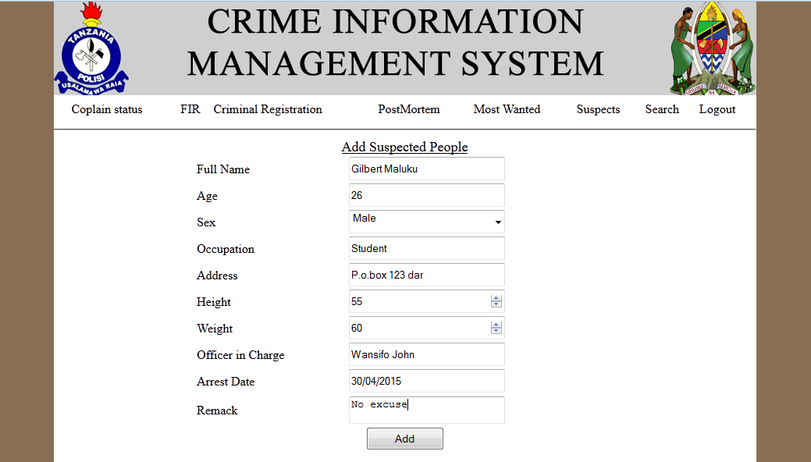

Here user can add detailed information about the suspected person

**Search:**

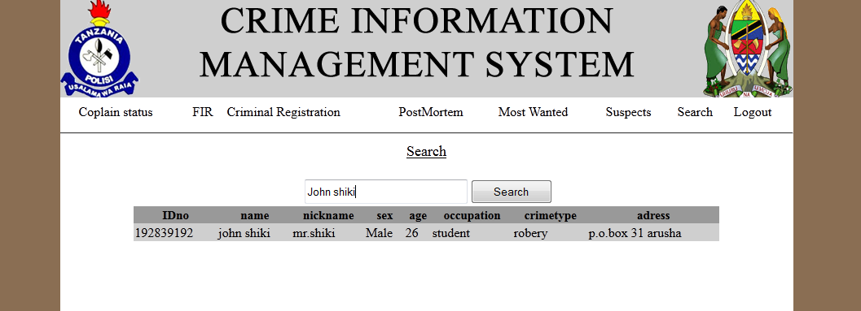

Here users can be able to search and view the criminal registered to the system

**CHAPTER FIVE: CHALLENGES**

**Time**

Due to time limited the project need more time for development so it cost us on our studies and normal activities so as to try to coupe up with a needed time.

**Cost**

Due to the cost of the stationary and other services the project uses much money for development.

**CHAPTER SIX: CONCLUSION**

**Summary**

It is very important that Tanzania police should know the level of crime in the country. By using this Crime Information Management System it helps the police to know whether to put in more effort in their fight against crime or not.

The reliability and efficiency of this System (Crime Information System) correct those weakness that are found in the existing method of tracking criminals

**Way Forward**

Efforts have been made to develop this Crime Information Management System. But there are still areas that may be considered as a further and important area to improve on, and my suggestion go thus.

There is the need for the Tanzania police stations to use this System.

**Definition of Terms**

**Crime:** A normative definition views crime as deviant behavior that violates prevailing norms cultural standards prescribing how humans ought to behave normally

**FIR:** First Information Report